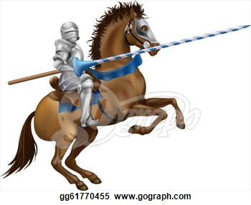
Laurel Park Middle School
Sixth Grade Supply List
2016 – 2017

4 - Two Inch Three Ring Binders
2 - Packs of Dividers (Do not open or label the dividers until you get to school)
2 - One Subject Spiral Composition Notebooks
1 – Composition Notebook (not spiral-bound)
4 - Two Pocket Folders with Fasteners and Pockets
1 - 5 Subject Notebook
1 - Box of Tissues
1 - Bottle of Hand Sanitizer
1 - Pack of Colored Pencils
1 - Pencil Pouch
Highlighters (yellow & orange)
Lots of Pencils-Preferably Lead Pencils
Index Cards
3 - Packs Loose Leaf Notebook Paper
6 – Glue Sticks
1 – Pack Construction Paper
1 – Hand Held Pencil Trimmer
1 – Pair of Small Scissors
1 – Box Zipper Storage Bags

